Every Figure in the APS Report, Explained
What each graph and diagram shows, in plain language, and why it earned a place in the report
The report has fourteen figures. Some are photographs proving a piece of hardware actually exists; some are diagrams of how something is wired together; most are graphs of a real measurement taken off the robot. This document goes through every one of them in the order they appear in the report, and for each asks the same three questions: what am I looking at, what do the numbers on it actually mean, and why does this particular picture matter enough to be in the report at all.
Nothing here changes or challenges anything in the report itself — it is a companion for reading it, written for viva preparation and for anyone coming to the figures without the surrounding technical background.

Part 1 — The robot itself

Figure 1 — The robot as built
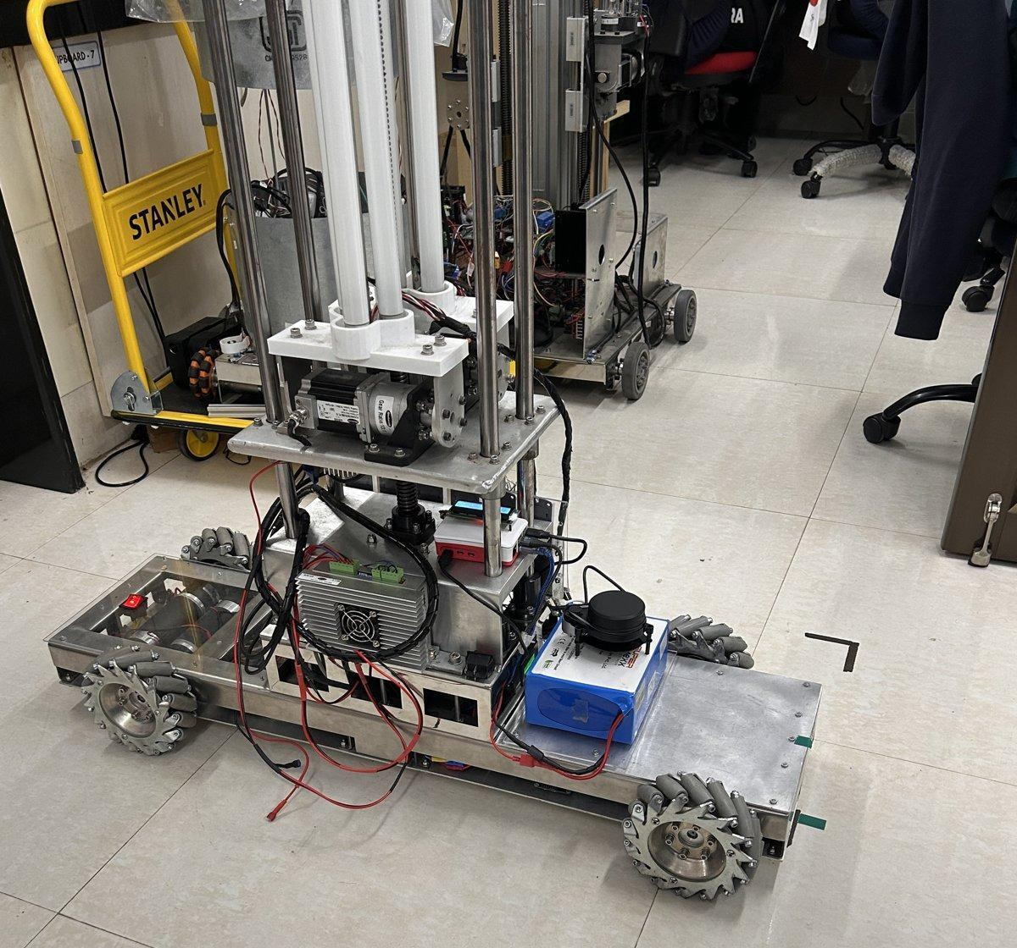
WHAT YOU’RE LOOKING AT
A photograph of the finished machine, taken in the lab on 11 August. It is a rectangular metal chassis about a metre long, riding on four “mecanum” wheels — wheels with a ring of small rollers around the rim, angled at 45°, which is what lets the whole robot slide sideways or spin on the spot without turning the wheels themselves. Standing up out of the middle is a vertical mast carrying three ultraviolet tubes and the motor for a small cargo arm. The black disc sitting on top of the battery, just in front of the mast, is the laser scanner (LiDAR) the robot uses to see the room.
THE NUMBERS, IN PLAIN ENGLISH
- 1.00 m long, 0.36 m wide across the wheels — about the size of a small suitcase trolley, sized to fit through a warehouse aisle rather than a normal corridor.
- The mast and the laser scanner sit at the same height, in the same horizontal slice of space. That single fact is the entire reason Figure 11, several pages later, exists at all.
WHY IT’S IN THE REPORT
This is the reference photo for the whole report — the physical object every later measurement is a measurement of. It is also doing quiet extra work: by showing the mast sitting right next to the laser scanner, it sets up the self-occlusion problem covered in Figure 11 before the report has even said the word “occluded.”

Figure 2 — Proving the robot agrees with itself about which way is forward
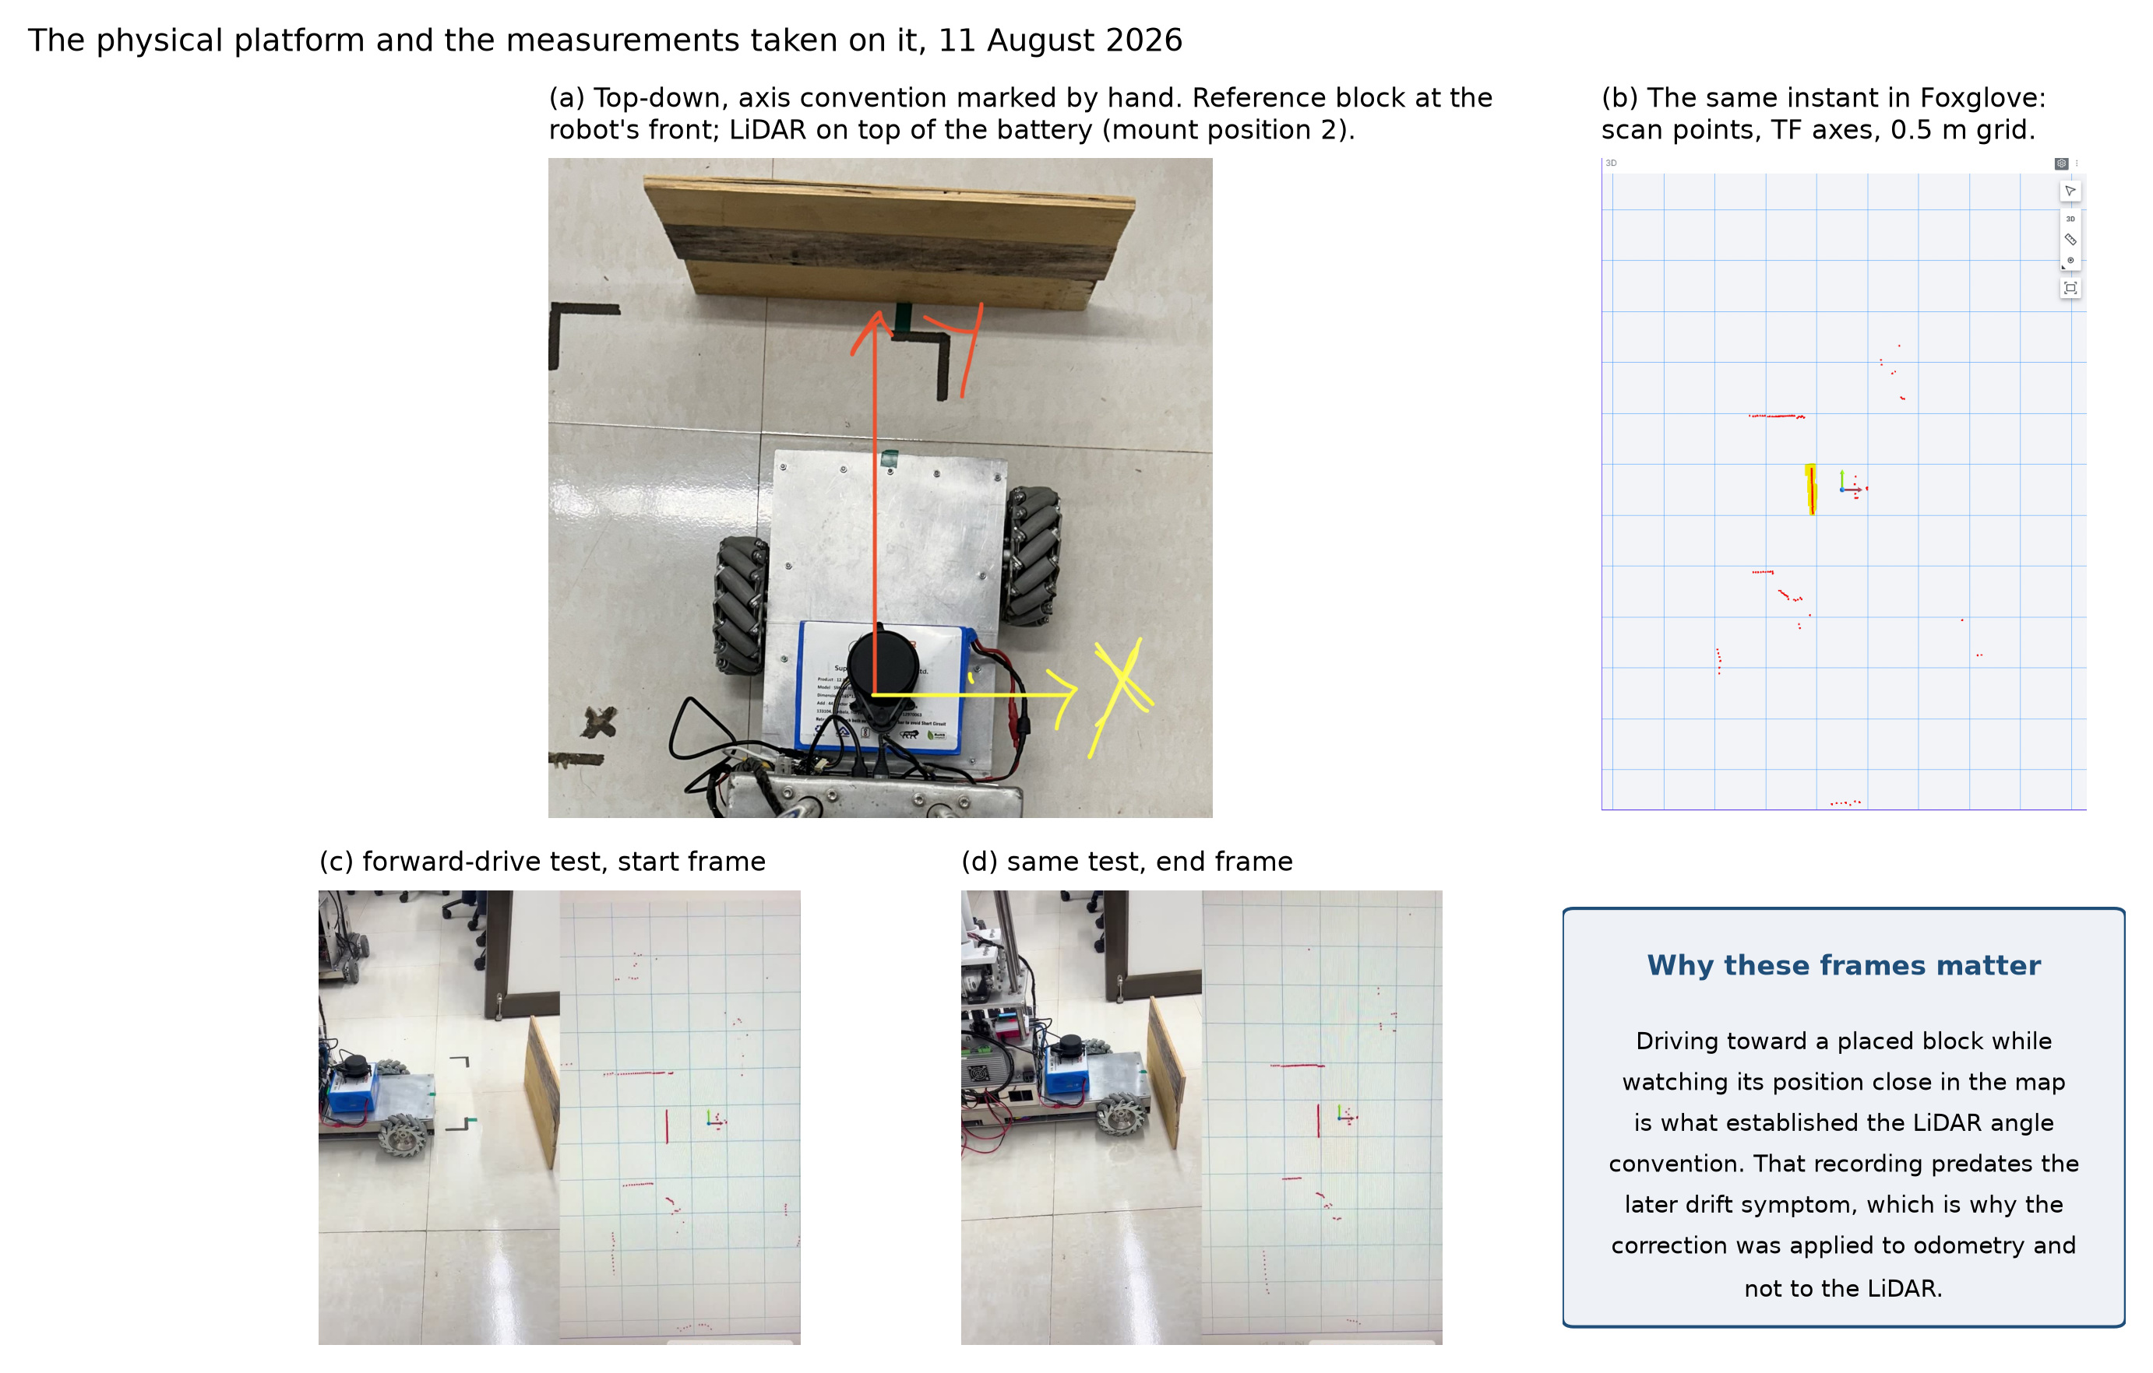
WHAT YOU’RE LOOKING AT
Four small snapshots side by side. (a) is a top-down photo of the robot with arrows drawn on by hand: a red arrow pointing to what the team has defined as “forward,” and a wooden block placed at the true front of the chassis as a physical reference. (b) is the same instant shown inside the visualisation software the robot uses — the little red dots are laser hits, and the coloured lines are the software's own idea of the robot's axes. (c) and (d) are the first and last frame of a short test where the robot was driven straight at that block, to check that “forward” in the software is the same direction as “forward” on the real chassis.
THE NUMBERS, IN PLAIN ENGLISH
- No measurements here — this figure is a proof, not a data table. The claim it proves is narrow but important: when the software says the robot moved “forward,” the robot actually moved toward that wooden block, not sideways or backward.
WHY IT’S IN THE REPORT
Small mistakes about which direction is “forward” sound trivial, but they are exactly the kind of error that causes a robot to drive the wrong way confidently. This figure is the paper trail proving the convention was settled by an actual physical test rather than assumed and hoped for.

Figure 3 — The wiring, laid out as a map
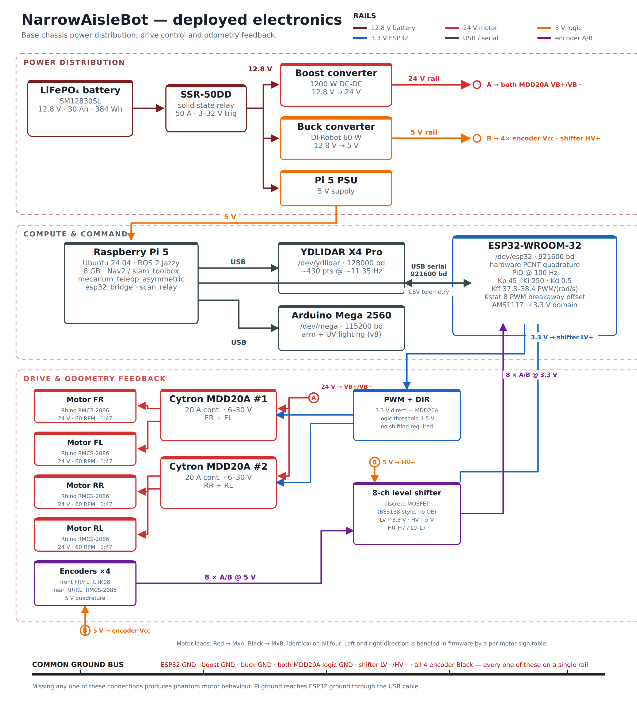
WHAT YOU’RE LOOKING AT
A colour-coded block diagram of every piece of electronics on the robot and how they connect: the battery and its voltage converters on one layer, the three computers (a Raspberry Pi, an ESP32 chip, and a leftover Arduino) on a second layer, and the motors with their speed sensors on a third. Each wire is coloured by which voltage it carries, so a stray connection would stand out at a glance.
THE NUMBERS, IN PLAIN ENGLISH
- Three power rails feeding three different jobs: one steady voltage for the motors, one for the two onboard computers, one for the sensors.
- The caption flags one specific, real mistake this diagram exists to prevent: the front pair of wheels and the rear pair use different speed-sensor parts with different wire-colour conventions, and that mismatch has already caused one wire to be connected wrong during a rebuild.
WHY IT’S IN THE REPORT
A generic wiring reference for this kind of robot would get two things wrong here specifically: it would assume identical speed sensors on every wheel, and it would assume a different voltage-conversion part than what is actually bolted in. This diagram is drawn from the real, as-built machine for exactly that reason — so the next person who opens the electronics box does not repeat a mistake that has already happened once.

Figure 4 — The lopsided wheel layout — the whole idea in one drawing
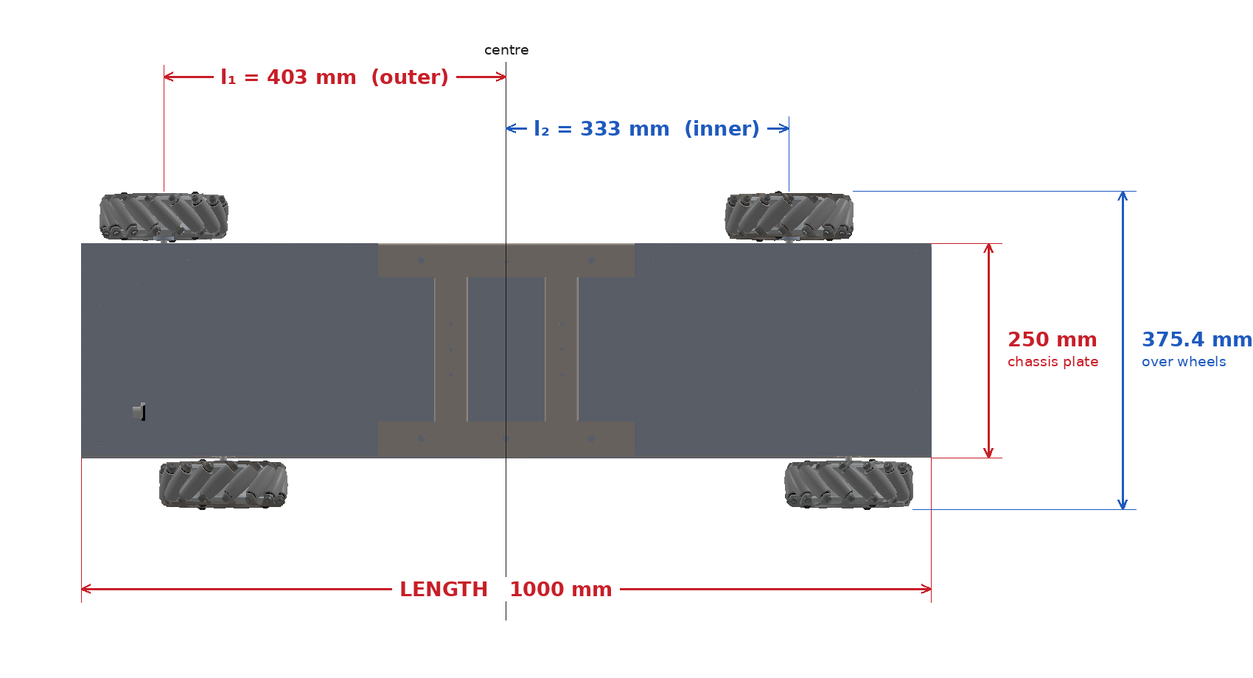
WHAT YOU’RE LOOKING AT
An engineering drawing, seen from directly above, of exactly where the four wheels sit relative to the centre of the robot. It is dimensioned in millimetres: the front-right and rear-left wheels sit 403 mm from the centre along the robot's length, while the front-left and rear-right sit only 333 mm from the centre — a 70 mm difference between the two diagonal pairs.
THE NUMBERS, IN PLAIN ENGLISH
- 403 mm vs 333 mm — a 70 mm difference between the two diagonal wheel pairs. On an ordinary four-wheeled robot those two numbers would be identical.
- Two slightly different “width” numbers show up elsewhere in the report: 360 mm, which is a tape measurement of the actual built machine, and 375.4 mm, which is calculated from the parts on the drawing. They differ by 15.4 mm because a tape measure and a CAD drawing are never perfectly identical things — the report is explicit that the 360 mm tape figure is the one every real test result is measured against.
WHY IT’S IN THE REPORT
This is the single idea the entire first half of the thesis is built around. Ordinary robots with these sideways-sliding wheels put all four wheels at the corners of a plain rectangle, which forces the whole machine to be as wide as that rectangle. Moving the two diagonal wheel-pairs to different distances from the centre — what the report calls “asymmetric” — lets the robot keep all the sideways-sliding ability while being built narrower, which matters because the entire point of the project is fitting into a warehouse aisle. This drawing is simply the proof of exactly how that idea was actually built, in millimetres.

Part 2 — The air-quality side project

Figure 5 — How the air-quality box is wired together
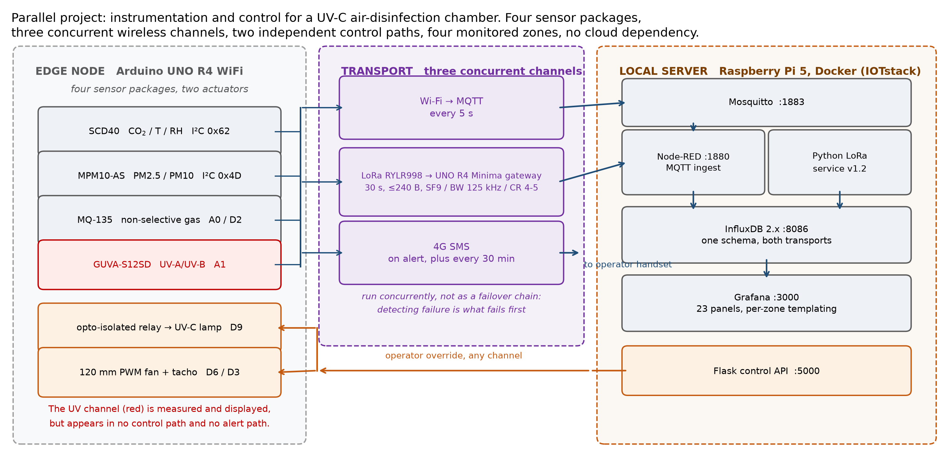
WHAT YOU’RE LOOKING AT
A second block diagram, for a completely separate piece of equipment: a box that watches air quality (CO₂, temperature, humidity, dust, UV light) and controls a germ-killing UV lamp and a fan. It shows four sensors feeding into one small computer, which then talks to a home-run server over three different wireless links at the same time — ordinary Wi-Fi, a long-range radio, and the mobile phone network — so the server always hears from it by at least one path.
THE NUMBERS, IN PLAIN ENGLISH
- Three communication paths running at once: Wi-Fi every 5 seconds, a long-range radio every 30 seconds, and a text message on alert. All three run all the time, rather than one being a backup that only switches on if another fails.
WHY IT’S IN THE REPORT
This documents the second, separate goal of the project: an air-quality box that reacts to what it actually measures instead of running a UV lamp on a blind timer. The decision to run three wireless channels simultaneously, rather than have two sit idle as backups, is explained here too — in a real network failure, the first thing that usually breaks is your ability to detect that something broke, so waiting to detect a failure before switching to a backup channel is often too late.

Figure 6 — The air-quality box, built and sitting on a bench
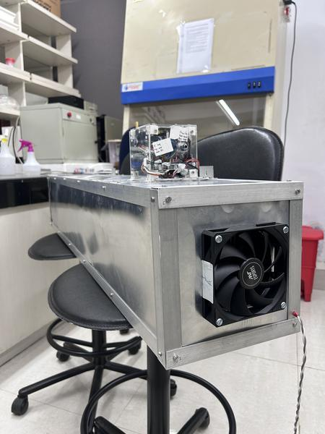
WHAT YOU’RE LOOKING AT
A plain photograph of that same box, physically built: a metal duct about the size of a shoebox stretched long, sitting on a lab bench, with a fan visible in one end and the sensor and control electronics mounted on top in a small enclosure.
THE NUMBERS, IN PLAIN ENGLISH
- No numbers on this one either — it exists purely to show that the diagram in Figure 5 is a real, physically assembled device and not just a plan on paper.
WHY IT’S IN THE REPORT
The same logic as Figure 1: a diagram is a plan, a photograph is proof the plan became a real object. This also heads off a possible mix-up — the robot itself carries its own separate UV lighting for a different job (visible on the mast in Figure 1), and this caption is explicit that the two UV systems are unrelated pieces of equipment.

Part 3 — Making the wheels do what they are told

Figure 7 — Teaching the controller how much push a motor actually needs
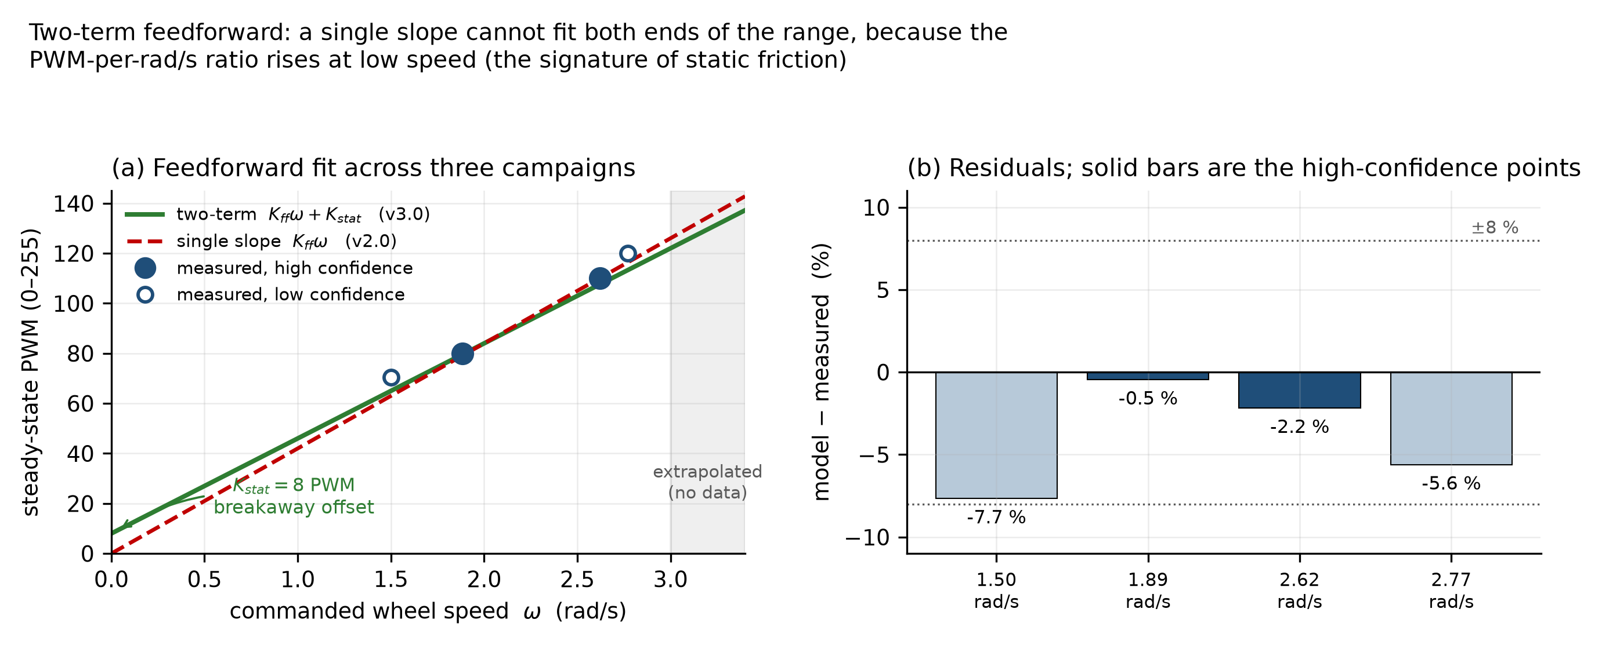
WHAT YOU’RE LOOKING AT
Two small graphs side by side. The left one plots how much electrical drive signal (“PWM,” on a scale of 0 to 255) a motor was given against how fast the wheel actually ended up spinning, with two candidate lines drawn through the measured points: a plain straight line, and a slightly bent line that starts a little higher. The right graph shows how far off each candidate line was from what was actually measured, as a percentage.
THE NUMBERS, IN PLAIN ENGLISH
- A plain straight-line rule under-predicts how much push a motor needs at low speed, because it ignores the fact that every motor needs a small extra “kick” just to overcome friction and start turning at all.
- The two-part rule used instead — a fixed kick plus a proportional term — matches the measured points to within about 8 %, and to within 2.3 % for the two most trustworthy measurements.
WHY IT’S IN THE REPORT
Every wheel on the robot is driven by this exact calibration. If a straight-line rule had been used instead, wheels would be under-powered at low speeds, and the report notes elsewhere that this specific problem caused an early version of the robot to stutter when trying to slide sideways, because one wheel in a matched pair was quietly getting less push than its partner for the same commanded speed.

Figure 8 — Proof that each wheel’s speed control actually works
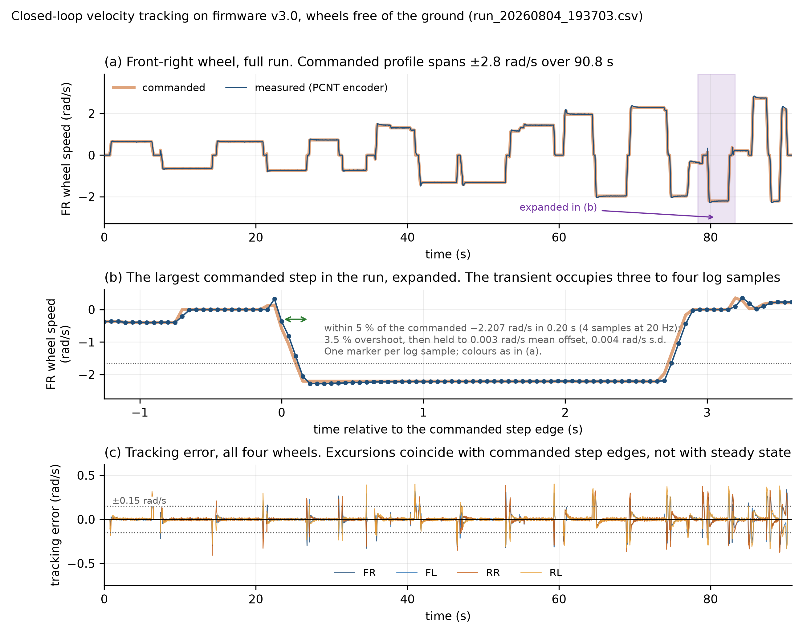
WHAT YOU’RE LOOKING AT
Three stacked graphs, all from one 91-second test with the wheels lifted clear of the floor. (a) shows one wheel's commanded speed (a thick orange line) laid directly on top of its actual measured speed (a thin blue line) for the whole test — they are close enough to be almost indistinguishable. (b) zooms into the single biggest speed change in that test, sample by sample, so you can see exactly how the wheel catches up to a new target. (c) shows the gap between commanded and actual speed for all four wheels, for the whole test, all at once.
THE NUMBERS, IN PLAIN ENGLISH
- The wheel reaches within 5 % of a newly commanded speed in 0.20 seconds, overshoots that target by 3.5 %, then settles down to sitting only 0.003 rad/s off the commanded value — a genuinely tiny error.
- Worth knowing: that 0.20-second figure includes some time the commanded speed itself was still ramping up to its new value, so it is not a pure measure of how fast the wheel alone reacts — a fair question to expect if this graph comes up.
WHY IT’S IN THE REPORT
Nothing else in the report means anything if the wheels do not reliably do what they are told — every distance driven, every position estimate, every map is built on top of this. This figure is the foundational proof that the lowest, most basic layer of the whole system is solid, checked before anything more complicated was layered on top of it.

Figure 9 — How much harder the wheels work once the robot’s weight is on them
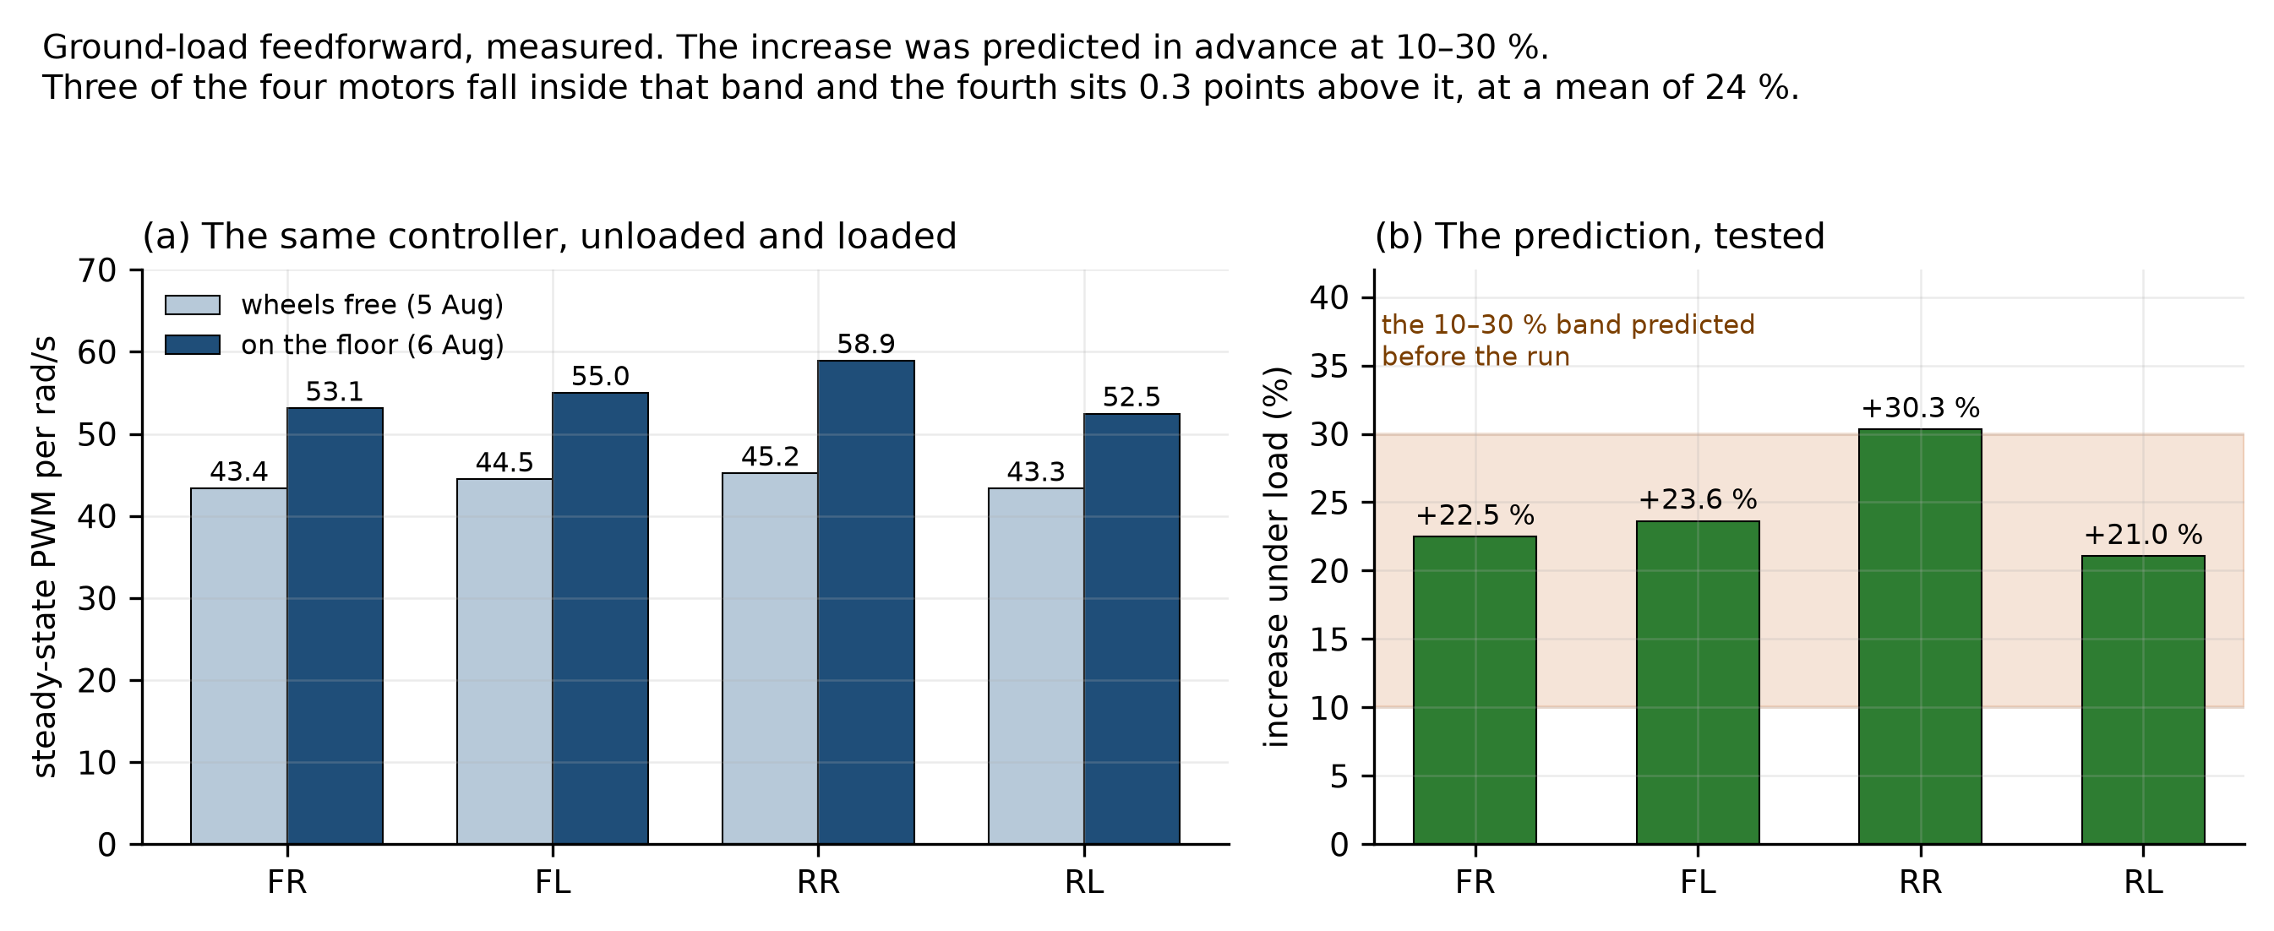
WHAT YOU’RE LOOKING AT
Two bar charts. The left one compares how much drive signal each of the four wheels needed to hold a given speed in two conditions: wheels spinning freely in the air (light blue bars) versus the robot sitting on the real floor under its own weight (dark blue bars) — the dark bars are always taller. The right chart turns that difference into a percentage increase for each wheel, and shades in the 10–30 % band that had been written down as a prediction before this test was ever run.
THE NUMBERS, IN PLAIN ENGLISH
- 24 % more drive signal needed, on average, once the robot's full weight is on the wheels — and this was predicted to land somewhere between 10 % and 30 % before the test was run, then checked against that prediction rather than explained afterward.
- Worth knowing: this 24 % figure comes from one test session. Two later sessions, on different patches of the same lab floor, gave smaller increases — 14 % and then 3 % — which shows the exact size of the effect depends on which bit of floor the robot happens to be sitting on, not only on its weight.
WHY IT’S IN THE REPORT
The speed controller in Figure 8 was tuned with the wheels in the air. Without knowing how much extra push the real floor demands, that same controller would quietly fall behind its commanded speed the moment the robot actually starts driving somewhere loaded, because it would be under-powering every wheel by roughly a quarter.

Figure 10 — Does the robot know where it is, just from counting wheel turns?
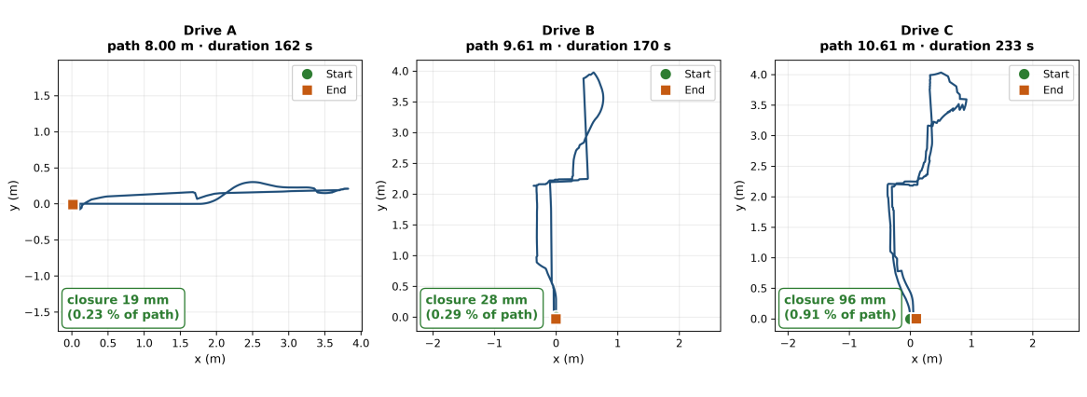
WHAT YOU’RE LOOKING AT
Three small maps side by side, each one the path a single test drive traced out, worked out purely from counting how far each wheel turned (no camera, laser, or GPS involved). Every drive started and ended at the same physical spot on the floor, marked with tape; the box under each map states how far the robot's own estimate of its position was from that real starting mark when the drive finished.
THE NUMBERS, IN PLAIN ENGLISH
- The three drives closed to within 19 mm, 28 mm, and 96 mm of their true starting spot, over routes of 8.00 m, 9.61 m, and 10.61 m — that is 0.23 %, 0.29 %, and 0.91 % of the distance actually travelled.
- The longest of the three, which also involved the most turning, had the largest error — a pattern the report follows up on later: turning seems to cost more positioning accuracy than straight driving does.
WHY IT’S IN THE REPORT
This is the cheapest, simplest way the robot has of estimating its own position — no camera, no laser, just counting wheel turns — and this figure establishes that it is accurate to under 1 % of distance travelled over these short routes. That number then becomes the yardstick the rest of the report measures every fancier positioning method against, including one later method (adding laser-based correction) that this yardstick reveals actually makes things worse rather than better.

Part 4 — Can it see, and can it build a map?

Figure 11 — The robot has a blind spot, and here is exactly how big it is
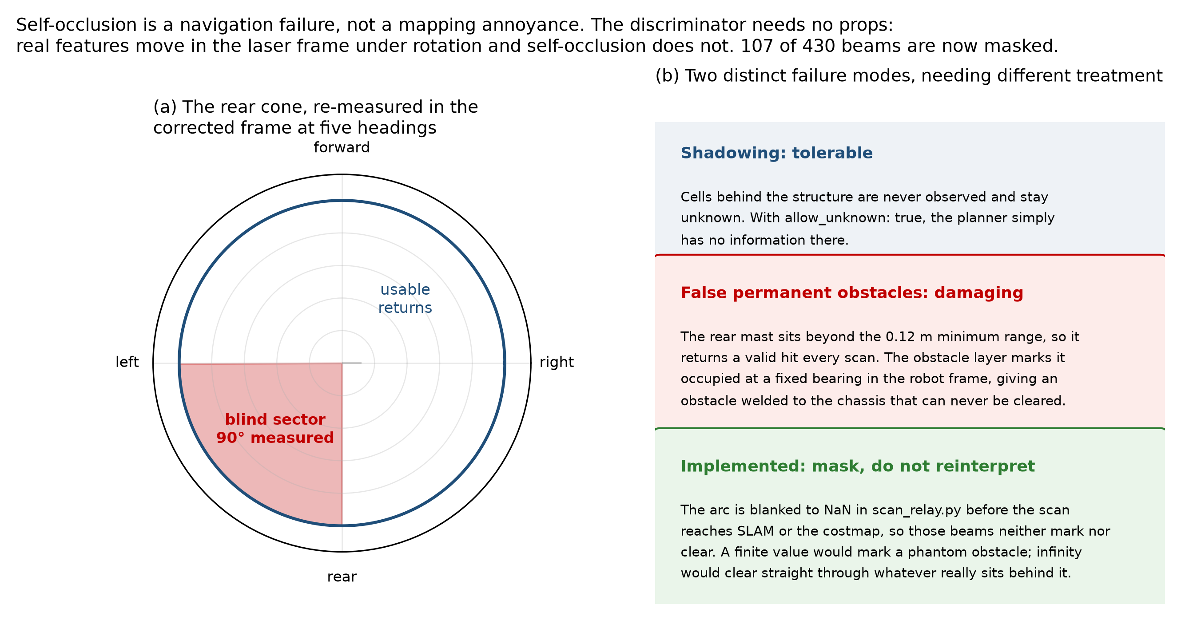
WHAT YOU’RE LOOKING AT
Two panels. The left one is a circular, radar-style diagram showing every direction around the robot that the laser scanner can see, with a red wedge — roughly a quarter of the full circle, toward the back — marked as blind, because the robot's own mast and cargo-arm hardware physically sit in the way of the beam in that direction. The right panel is plain text explaining two different things that blind spot could cause, and which one the team chose to prevent.
THE NUMBERS, IN PLAIN ENGLISH
- The blind wedge covers about 90 degrees — a quarter of the full circle — and blocks 107 of the 430 individual laser readings the scanner takes on each spin.
- The fix chosen was simply to tell the software to throw those 107 readings away before they reach the mapping or navigation code, rather than trying to make sense of them.
WHY IT’S IN THE REPORT
Before this was diagnosed, the laser could in principle mistake its own mast for a permanent wall stuck to the robot, appearing in the exact same spot no matter which way the robot turned — the software equivalent of an invisible wall glued to the machine. This figure documents both the size of the problem and the fix: simply telling the software to ignore that wedge of readings entirely, before it ever reaches the mapping code.

Figure 12 — Which way of driving actually builds a map, and which wastes time
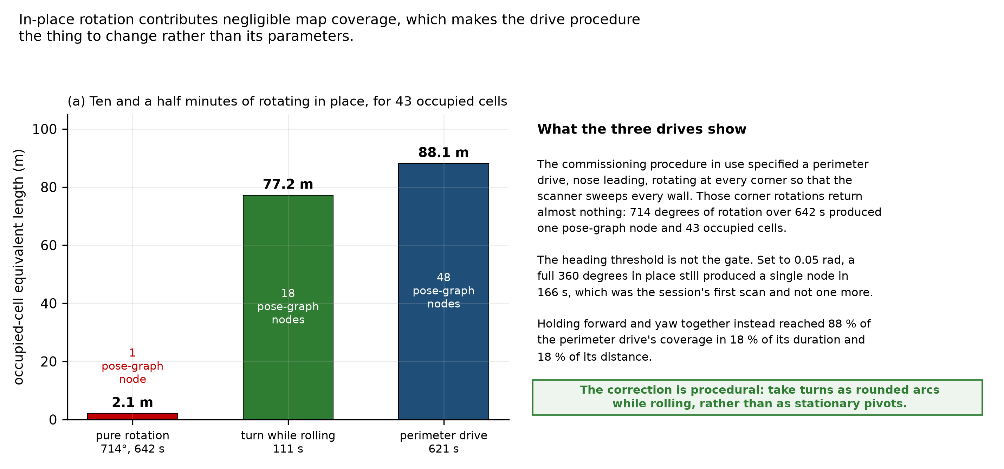
WHAT YOU’RE LOOKING AT
A bar chart comparing three different ways of driving the robot around, and how much new “wall” each style added to the map. Turning the robot in place at a fixed spot, kept up for over ten minutes, is the first bar; driving a short curved path while continuously moving forward is the second; a full lap around the whole room is the third.
THE NUMBERS, IN PLAIN ENGLISH
- Ten and a half minutes of spinning in place produced only 2.1 m worth of new wall on the map. A 111-second curved path while still moving forward produced 77.2 m — 88 % of what a full lap of the room eventually produces, in under a fifth of the time a full lap takes.
WHY IT’S IN THE REPORT
This one changed an actual, everyday habit rather than any piece of hardware or code. The commissioning routine used to have the robot pause and spin at every corner to “look around” — a very natural thing to try, and this chart is the evidence that it barely works with this particular mapping software. The team changed the driving procedure afterward: keep the robot moving through every turn instead of stopping to spin, because that is what the software actually rewards. It is presented as one of the most valuable findings of the whole project precisely because the fix was free — no new part, no new code, just driving differently.

Figure 13 — Three attempts at mapping the lab, side by side
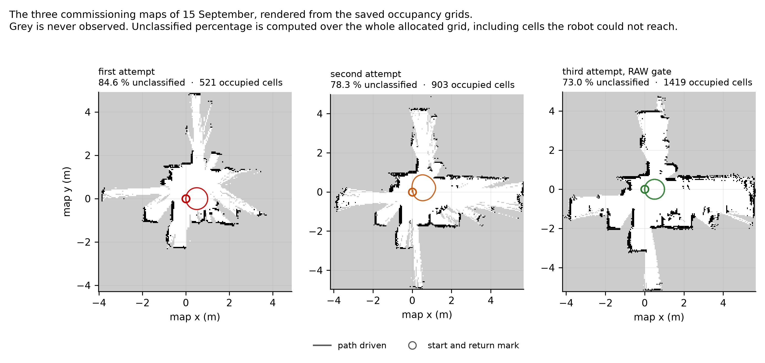
WHAT YOU’RE LOOKING AT
Three floor-plan images, one per test drive, all made from the same cross-shaped lab room on the same day. Black lines are walls and furniture the laser actually detected with confidence, grey shading is floor area the robot never got close enough to see and so knows nothing about, and the thin coloured line threaded through each map is the literal path the robot drove.
THE NUMBERS, IN PLAIN ENGLISH
- All three drives returned successfully to within a few centimetres of their starting mark, and the wall shapes they did manage to see agree with each other and with the real room.
- The grey “never observed” area covers the majority of every map — not because the laser or the software failed, but because the lab's open floor space is small enough that the robot simply cannot drive far enough to see the rest of the room in one loop.
WHY IT’S IN THE REPORT
This figure makes the report's central mapping problem visible at a glance rather than requiring a paragraph of explanation: the maps are incomplete not because anything on the robot is broken, but because the lab does not offer enough open floor for the robot to drive a big enough loop to see the rest of the room. One of four pass/fail rules set in advance for judging a map “good enough,” the amount of unobserved area, is the one rule all three maps fail here, and this figure is the honest reason why.

Part 5 — The scorecard

Figure 14 — The report card: what is proven, what is not, and why
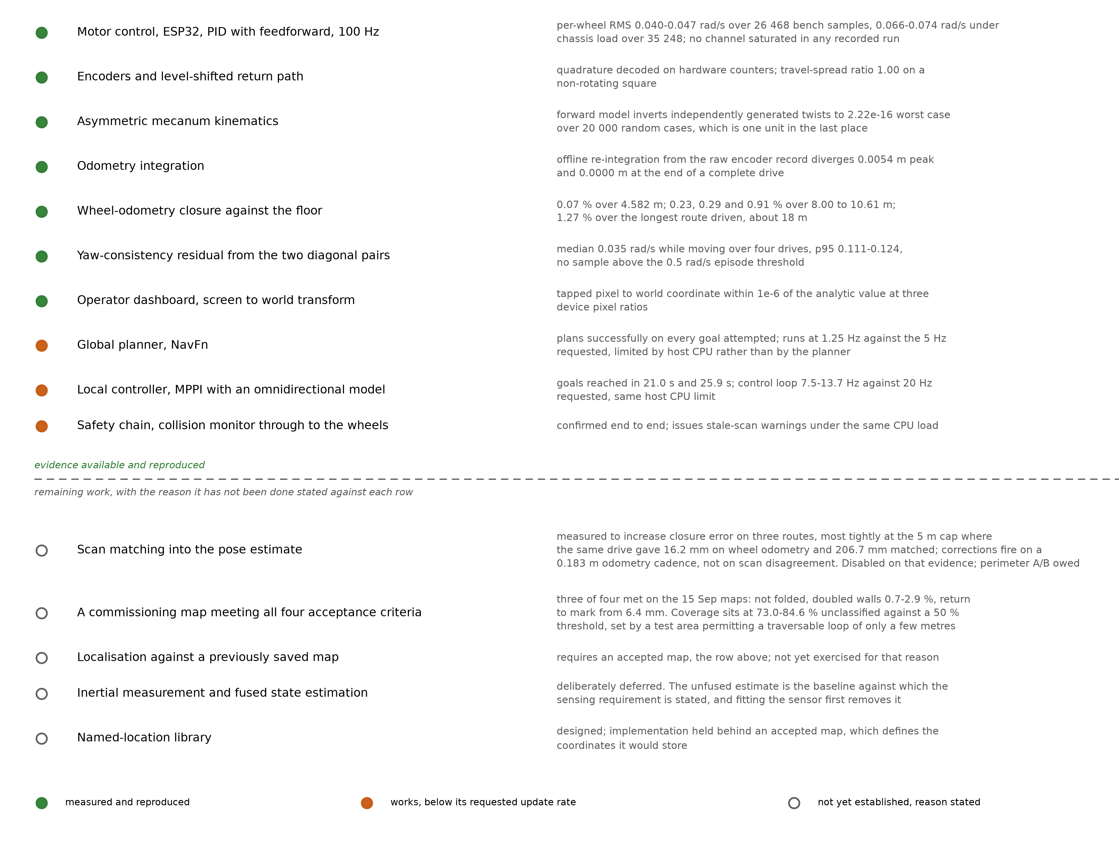
WHAT YOU’RE LOOKING AT
A long checklist covering every subsystem on the robot — motors, wheel-speed sensors, the maths behind the wheel layout, position tracking, the laser map, the path planner, the driving controller, the emergency-stop chain, matching against a saved map, an added motion sensor, and a memory for named locations — each marked with a solid green dot (measured and working), a solid orange dot (working, just slower than hoped), or a hollow circle (not yet proven), with a short note next to every single one explaining exactly what evidence backs it up, or exactly why it is not yet checked off.
THE NUMBERS, IN PLAIN ENGLISH
- Seven items are fully green: motor control, speed sensing, the maths for the lopsided wheel layout, position tracking, matching where the robot thinks it is against where it actually is, the touchscreen control panel, and the yaw-consistency check. Three are orange: the path planner, the driving controller, and the emergency-stop chain all work correctly but run a bit slower than the team originally hoped for, because the onboard computer is doing a lot at once.
- Five are still hollow, and three of those five share one root cause stated plainly on the figure itself: the lab is too small to drive the loop these tests need. That is not a flaw in the robot — it is a flaw in the available test space, and the figure says so rather than hiding it inside a vague “future work” line.
WHY IT’S IN THE REPORT
This is the figure to remember above all the others. Instead of a vague closing claim that “the robot mostly works,” it grades every single claim in the report by the actual evidence behind it, and for everything not yet proven it states the specific reason rather than leaving a silent gap. A reader — or an examiner — can see the entire state of the project in one look, and see that most of what remains unfinished has one shared cause rather than being a scattered list of separate failures.

